Maryland SAL License Plate
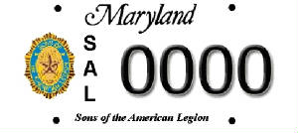

The Detachment of Maryland can now boast of having our own license tag.

These tags will be issued by the Maryland Motor Vehicle Administration (MVA) and will replace your current license plate on your vehicle. The Sons of The American Legion emblem is in the actual colors of blue, gold, and brown with all other lettering in black, as displayed above.

To obtain your SAL tags collect:
- One time processing fee of $30; checks payable to:
The American Legion Department of Maryland
- A copy of your current vehicle registration (This vehicle must be registered in your name)
- A copy of your current SAL Membership card or your SAL membership ID for validation
- Your phone number

Send all of the above items to:
Detachment of Maryland
3115 Orchard Ave
Baltimore, MD 21234

After your information has been verified, you will be mailed a MVA form that you will need to fill out and return to the Detachment. This form will then be processed, and your SAL tags will be mailed directly to you from the MVA.

For additional information, please contact Detachment Adjutant Bill Matoska (matoskaw@yahoo.com)

